A Hybrid Demand Forecasting System For Lumpy And Intermittent Data

Abhishek Verma

Research Proposal

May 2023

# Abstract

Demand forecasting is probably the most important job of demand management that helps businesses to anticipate customer demand and plan accordingly. However, demand of some product varies too much with time which generates lumpy and intermittent patterns. Demand of these products are more difficult to forecast. Intermittent demand occurs when there are many periods with zero demand and some periods with positive demand. Lumpy demand occurs when there are large variations in the demand size across periods. For intermittent forecasting traditionally algorithms often focus on improving performance measure metrics, smoothing the non-zero sales or dealing with issue in two phases 1) prediction of demand occurrence 2) Prediction demand size. Hybrid multi-step and multi-seasonal forecasting algorithms have tried to solve the issue of multi seasonality, horizon, and multi-level issue in retail supply chain forecasting. This research proposes a novel hybrid three-step forecasting model for lumpy and intermittent demand series by addressing factors such as Minimum-Order Quantity (MOQ), Moving Cumulative demand for a fixed period, Demand coverage (DC) as percentage of cumulative demand, demand interval DI (Overall, Moving). The first phase predicts the sales using transformer based neural network and factors such as trend, seasonality and promotions. Second phase uses forecasts from earlier algorithm and predicts adjusted forecast using modified Syntetos-Boylan algorithm and considering factors such as DI, CDI and cumulative DC. The third phase performs post-forecast processing to predict zero sales and avoid excess inventory problems. This research is going to help in intermittent demand forecasting with multi step and horizon demand series accurately.

Table of Contents

Abstract ii

CHAPTER 1: INTRODUCTION 1

1.1. Background of the Study 1

1.2. Problem Statement 1

1.3. Aim and Objectives 2

1.4. Research Questions 2

1.5. Significance of the Study 3

1.6. Scope of the Study 3

1.6.1. In-scope 3

1.6.2. Out of scope 4

CHAPTER 2: LITRATURE REVIEW 5

2.1. Introduction 5

2.2. Croston based Modeling 5

2.3. Multi-stage seasonality models 6

2.4. Hybrid multi-stage model using machine learning and deep learning 7

2.5. Summary 9

CHAPTER 3: Research Methodology 11

3.1. Data Description 12

3.2. Data Exploration and Pre-process: 13

3.3. Feature Engineering 13

3.4. Hybridization of Neural Network mSBA, and Quantile Regression for Demand Forecast 14

3.5. Performance evaluation 14

CHAPTER 4: Requirements Resources 15

4.1. Software Requirement 15

4.2. Hardware Requirement 16

CHAPTER 5: Research Plan 16

References 16

**LIST OF TABELS**

Table 1: Data Description 9

Table 2: Forecast Evaluation Parameters 12

Table 3: Software Requirement 12

**LIST OF FIGURES**

Figure 1.1: Example Intermittent Vs. Regular Demand 1

Figure 3.1. Research Methodology Flowchart 12

Figure 5.1: Research Plan 17

**LIST OF ABBRIVATIONS**

AdaBoost : Adaptive Boosting 4

ANN : Artificial Neural Network 4

CDI : Current Demand Interval 1, 6

CV: Coefficient of Variation 10

DC : Demand Coverage 6, 7

DI : Deamnd Interval 1, 6, 7

LR : Logistic Regression 4

LSTM : Long -Short-Term-Memory 4, 5

MAAPE : Mean Arctangent Absolute Percentage Error 11, 12

MAPE: Mean Absolute Percentage Error 11, 12

MASE: Mean Absolute Scaled Error 11, 12

MIMO : Multi-Input and Multi-Output 4, 5

MLP : Multi-Layer Perceptron 4, 5

MOQ : Minimum Order Quantity 7

RF : Random Forest 4

RMSE : Root Mean Square Error 11, 12

SARIMA : Seasonal Autoregressive Integrated Moving Average 3

SBA : Syntetos-Boylan Approximation 2, 6, 11

SBJ : Shale-Boylan-Johnston 2

SKUs : stocks keeping units 1

SVR : Support Vector Regressor 4

TBATS : Trigonometric seasonality, Box-Cox transformation, ARIMA errors,Trend ,Seasonality 3, 4, 5

TFT : Temporal-Fusion-Transformer 5, 6

TSB : Teunter-Syntetos-Babai 2

XGBoost : Extreme Gradient Boosting 4

# INTRODUCTION

## Background of the Study

A time-series is sequence of data points that are arranged by time. It allows us to examine how a variable change over time and to predict its future behaviour. It can be used to analyse trends, pattern, cycle in various domains and forecast future data. Time-series is very critical especially in retail domain where you need to forecast thousands of stocks keeping units (SKUs) comprising of different characteristics and nature where slow moving and quite often seasonal and irregular demand pose a serious challenge for forecasting the series with accuracy. This kind of series where we have zeros in data and a series is not continuous and demand occurs at an interval that kind of series is called intermittent time series, this kind of series pose challenges for forecasting, as they require different methods than regular time series. Below figure1.1 “Type of demands” shows example of

Figure .: Type of demands

Moreover, as stated by Johnston and Shale (Johnston et al., 2003) that intermittent demand usually generates only 40% of total store income, however requires 60% of total investment.

Thus, forecasting time series with intermittent or sporadic data in time (Croston, 1970; Williams, 1984; Eaves and Kingsman, 2004; Boylan et al., 2008), is a critical for many applications on supply chain and manufacturing, raw material sourcing to resource allocation, production to the prediction of end- user consumption. Traditionally, forecasting methods often struggle to capture the irregular patterns and uncertainty of such data. Therefore, various methods have been developed to deal with this problem.

Our proposed method in the research paper will incorporate cumulative demand, current short term cumulative demand percentage of long-term cumulative demand, current demand interval (CDI), average demand interval (ADI), demand interval (DI) as factors and use temporal fusion transformer (Lim et al., 2021) for stage-1 time-series forecasting. In stage-2 modified Syntetos and Boylan (SBA) will be used to model lumpiness in the time-series data. Further, quantile regression will be used to predict the lower and upper boundaries.

## Problem Statement

## Aim and Objectives

Main aim of this research is to propose a three phased hybrid model for intermittent and lumpy time-series data.

The following research objectives are derived from the main aim of the study:

* Create Demand Interval (DI), Current Demand Interval (CDI), Demand Coverage (DC) and analyze effects of above in intermittent demand forecasting
* Use of Temporal Fusion Transformers (TFT) for demand forecast using inputs from first phase, and other factors such as trend, seasonality and promotions.
* Predict intermittent demand by modified SBA and TFT for forecasting
* Propose a quantile regression as post processing method to predict zero sales and avoid excess inventory

## Research Questions

The research problem and related research in this area lead to following research questions:

**Question1:** How can we reduce the high bias issue in intermittent demand series, when we have dynamically changing demand interval?

**Question2:** Can a hybrid of temporal fusion transformer and modified SBA algorithm outperforms other algorithms in intermittent demand?

**Question2:** Can we address issue of multi-stage and multi-level intermittent demand forecasting for dynamic changing series with global algorithm?

## Significance of the Study

Forecasting lumpy and intermittent time series is challenging and difficult as demand patterns are sporadic and variable. However, these types of demand are common in retail, where many Stock Keeping Units (SKUs) have periods of zero sales embedded with positive sales of varying magnitudes. It is important to forecast lumpy and intermittent demand accurately as it is crucial for inventory management and can reduce stock-outs, excess inventory, and markdown costs. Several methods have been proposed to deal with lumpy and intermittent demand, such as Croston's method, score-driven models, and deep learning approaches. However, these methods may not account for some important factors that affect retail demand, such as minimum-order quantity (MOQ), moving cumulative demand, demand coverage (DC), and demand interval (DI). These factors can help optimize inventory levels and avoid excess or insufficient stock.

The research will able to address following prospective into the forecasting:

Lot of Sporadic demand occurs at fixed interval or in multiples, the study will be able to provide

* Effect of overall demand interval, current demand interval
* Cumulative demand coverage over a specific period of time
* Demand Coverage as a percentage of cumulative demand

Suggested algorithm will be able to forecast accurate inventory to avoid excess or loss of sales

## Scope of the Study

### In-scope

The study will develop Tri -phased hybrid time-series forecasting model for intermittent demand series. Research considers retail specific parameters into consideration.

Scope of the study involves demand forecasting considering demand coverage and cumulative demand coverage over a specific time period. Secondly research aims to predict intermittent pattern in time-series and penalize the forecast in case of continuous zero sales. 3) Thirdly research will predict the quantiles to maintain correct level of inventory.

### Out of scope

Study does not intend to optimize the inventory level. Scope of study is limited to 14 days short term forecast and 54 days long term forecast.

# LITRATURE REVIEW

## Introduction

Historically many researchers have tried solve intermittent demand forecasting problem. We can segregate related research into several parts

1. Corston based Models
2. Models considering multiple seasonality
3. Hybrid models using ensemble models
4. Multi-stage model hybrid models using machine and deep-learning algorithms.

## Croston based Modeling

One of the earliest and most widely used approach that has been popular for predicting sporadic demand was introduced by Croston (Croston, 1970) . This method uses exponential smoothing and splits the time series into two components: the average demand size and the demand interval that is time between demands. However, Croston’s suggested approach had several drawbacks such as sensitive to the smoothing parameter and producing biased predictions.

In 1970, A. Vijaya Rao (Rao, 1970) criticizes the use of exponential smoothing for forecasting intermittent demands in stock control systems. His research paper “A Comment on: Forecasting and Stock Control for Intermittent Demands” shows that this method leads to excessive stock levels and suggests a new method that includes the estimation of demand size and demand frequency. Additionally, he also added the safety stock levels to provide protection against being out of stock. However, Corston’s model was proved positively biased (Syntetos and Boylan, 2001).

Later, Syntetos-Boylan approximation (Syntetos et al., 2005) (SBA), the Shale-Boylan-Johnston approximation (SBJ) (Johnston et al., 2003), and the Teunter-Syntetos-Babai (TSB) method (Teunter and Duncan, 2009) tried to improve the accuracy and reduce the bias by introducing the different correction factor.

Further, Syntetos, Boylan & Croston (Syntetos et al., 2005) suggested rules that categorise time-series into four parts. 1) Smooth easy to forecast low in intermittence and erraticness 2) Erratic with low intermittency but high erractiness 3) Lumpy with high in intermittency and erractiness 4) Intermittent high intermittence and low erractiness.

In 2021, Modified Teunter-Syntetos-Babai (mTSB) (Yang et al., 2021) method suggested improvements in the SBA algorithm and estimates the probabilities of both zero and non-zero occurrence. For zero occurrence algorithm compares the actual occurrence probabilities with predicted probabilities of previous period and estimates the next probability by Bernoulli distribution. While these methods rely on exponential smoothing and assume a constant demand size and inter-demand interval, which may not hold true for irregular demand series.

Additionally, researchers also suggested the lumpy series with high irregularities and erractiness in data are tougher to forecast (Bartezzaghi and Kalchschmidt, 2011; Petropoulos and Kourentzes, 2015). The previous methods of forecasting had some limitations: they did not account for multiple seasonality, which means the presence of more than one periodic pattern in the data, and they could not produce forecasts for more than one step ahead. We needed a better approach to handle these challenges.

## Multi-stage seasonality models

Adaptive trend and seasonality (ATA)(Ekiz Yilmaz et al., 2019) method, is an alternative to exponential smoothing method can handle nonlinear trends and seasonal patterns. It uses weighted moving average to update the level, trend, and seasonal components of the time series and adjusts the weights based on the forecast errors. Yilmaz (Ekiz Yilmaz et al., 2019) modified the ATA method to forecast intermittent demand by applying it to the demand size and inter-demand interval components separately.

Different types of models, like autoregressive integrated moving average (ARIMA), The seasonal autoregressive integrated moving average (SARIMA) (Hyndman and Athanasopoulos, 2018), Holt-Winters (Winters, 1960; Holt, 2004) are also being used to capture single seasonality in time-series data for future forecast. Later, TBATS (de Livera et al., 2011; Taylor and Letham, 2018) model considering several components T: Trigonometric seasonality, B: Box-Cox transformation A: ARIMA errors T: Trend S: Seasonality. TBATS summarizes complex exponential smoothing for multiple seasonality by adding ARIMA and Box-Cox transformations. For effective and correct estimation of model parameters model uses state space formulation that allows efficient computation. Further Prophet(Taylor and Letham, 2018) also works well on multiple – irregular seasonal components by adding components such as Fourier series, holiday, special events, which are being used further to fit curve to historical data and forecast future.

## Hybrid multi-stage model using machine learning and deep learning

Although models used above performed better then predecessors, however, they did not include the effects of other different covariates such as promotions (Distributers, Retailers) sell-in (sales done to retailers from manufactures) sell-out (sales by retailers to consumers), inventory levels, promotion pricings, pricing and promotions strategies of competitors, and new innovations that is new products (Sillanpää and Liesiö, 2018) . All these parameters add uncertainties and complexities in forecasting long term forecast and supply chain (Mohammed, 2020). Considering above hybrid machine learning models gave researchers required flexibility to add required complexities in the model structure and perform better in retail supply chain forecasting (Aye et al., 2015) .

Gutierrez and Mukhopadhyay in 2008 used neural network models for intermittent demand forecasting (Gutierrez et al., 2008). Research paper in 2005 (Pai and Lin, 2005) used hybrid of ARIMA and support vector regressor (SVR) that performed better as compared to standard algorithms. Later in 2007 (Aburto and Weber, 2007) used different combinations of algorithms using ARIMA and Artificial Neural Network (ANN) for forecasting that again outperformed traditional methods. In 2019 research paper “Machine learning applications in time-series hierarchical forecasting” (Abolghasemi et al., 2019) used ANN, extreme gradient boosting (XGBoost) and SVR to forecast sales disaggregation factor for each node by utilizing retail supply chain factors such as promotions. Recent research paper (Mitra et al., 2022) researchers compared hybrid machine learning models for demand forecasting for a retail channel company where they compared different individual machine learning algorithms random forest (RF), XGBoost, adaptive boosting (AdaBoost), and ANN with hybrid algorithm RF- XGBoost-LR. Here also they proved that hybrid algorithms performed much better than as compared to individual algorithms.

Even though we saw huge advancements in algorithms, long-term forecasting intermittent and lumpy data accurately is still a huge problem, a research paper in 2022 tried to solve the problem by taking multi-stage hybrid forecasting approach (Sousa et al., 2022) . This research talks about solving four main issues of forecasting 1) forecasting intermittent demand series 2) multi-stage forecasting 3) multi seasonal forecasting 4) correct model selection across multi-stage forecasting. Here researcher has taken multi-step ensemble recursive forecasting approach. Model uses recursive lag and multi-input and multi-output MIMO approach for multi-step ahed forecasting. The paper proposes weighted ensemble models that combines the forecasts of Multi-layer Perceptron (MLP), Long -Short-Term-Memory (LSTM), Prophet and TBATS.

A research paper published in 2022 addressed the challenge of accurately forecasting intermittent and lumpy data over a long-term horizon by proposing a multi-stage hybrid forecasting approach (Sousa et al., 2022) . The paper aimed to solve four main issues of forecasting: 1) forecasting intermittent demand series, 2) multi-stage forecasting, 3) multi-seasonal forecasting, and 4) correct model selection across multi-stage forecasting. The authors adopted a multi-step ensemble recursive forecasting approach, where the model used recursive lag and multi-input and multi-output (MIMO) approach. Ensemble models included Multi-layer Perceptron (MLP), Long -Short-Term-Memory (LSTM), Prophet and TBATS. Recently, Transformer-based diffusion probabilistic model (TDP) (Chang et al., 2023) was used for sparse time-series forecasting, which outperformed existing probabilistic time-series algorithms. Algorithm uses transformer and diffusion process to model uncertainty in data.

The hybrid multi stage method we discussed earlier has some advantages over the older and traditional methods, but it also has some limitations. It is not very accurate when it comes to forecasting data that has multiple levels and horizons, such as different categories of products in a retail store. For example, haircare products, foods and beverages, and ice-cream products may have different patterns, seasonality, sales volume, distribution channels, and promotion mechanisms. These categories may also be influenced by various external and internal factors, such as changes in consumer demand and preferences, distribution changes, and market conditions. These factors may affect the same product differently depending on the category it belongs to. Considering this some researchers from Google cloud and oxford proposed a novel approach Temporal-Fusion-Transformer (TFT) (Lim et al., 2021) that is based on transformer and attention mechanism which combines multi-horizon, high performance, temporal relationships and dynamics at different levels. It can handle sophisticated blend of inputs, such as static covariates, both known and unknown future inputs, and other exogenous time series. TFT in contrast to learning the variable importance of temporal features selection (Choi et al., 2016) with the help of transformers it fuses relevant global features from different sources and analyses the global relationship and behaviour. It also learns how to capture temporal patterns such as lags and seasonality at various scales using recurrent layers for local processing and self-attention layers for long-term dependencies.

## Summary

Although, TFT tries to fit multiple gaps in multi stage and horizon forecasting by learning the local and global temporal relationships and patterns, it does not specifically solve the intermittent demand issues, thus lacks the correct magnitude of the distribution when demand is intermittent resulting high bias. Our proposed research paper will try to fill the gaps by taking hybrid approach of TFT- modified Syntetos and Boylan (mSBA) -Quantile regression using recursive forecasting approach.

# Research Methodology

As in research review section we have saw that hybrid multi-level and multi-stage modeling structure have performed better. However, they have left several open gaps, such as demand coverage at specific time interval, demand interval, overall demand interval, short term demand interval etc. at different level such as demand interval and demand coverage will be different for hair care category with food and beverages category. Our proposed hybrid multi stage methodology including TFT, modified SBA and quantile prediction will try to fill current gaps. Research methodology flowchart is given below.

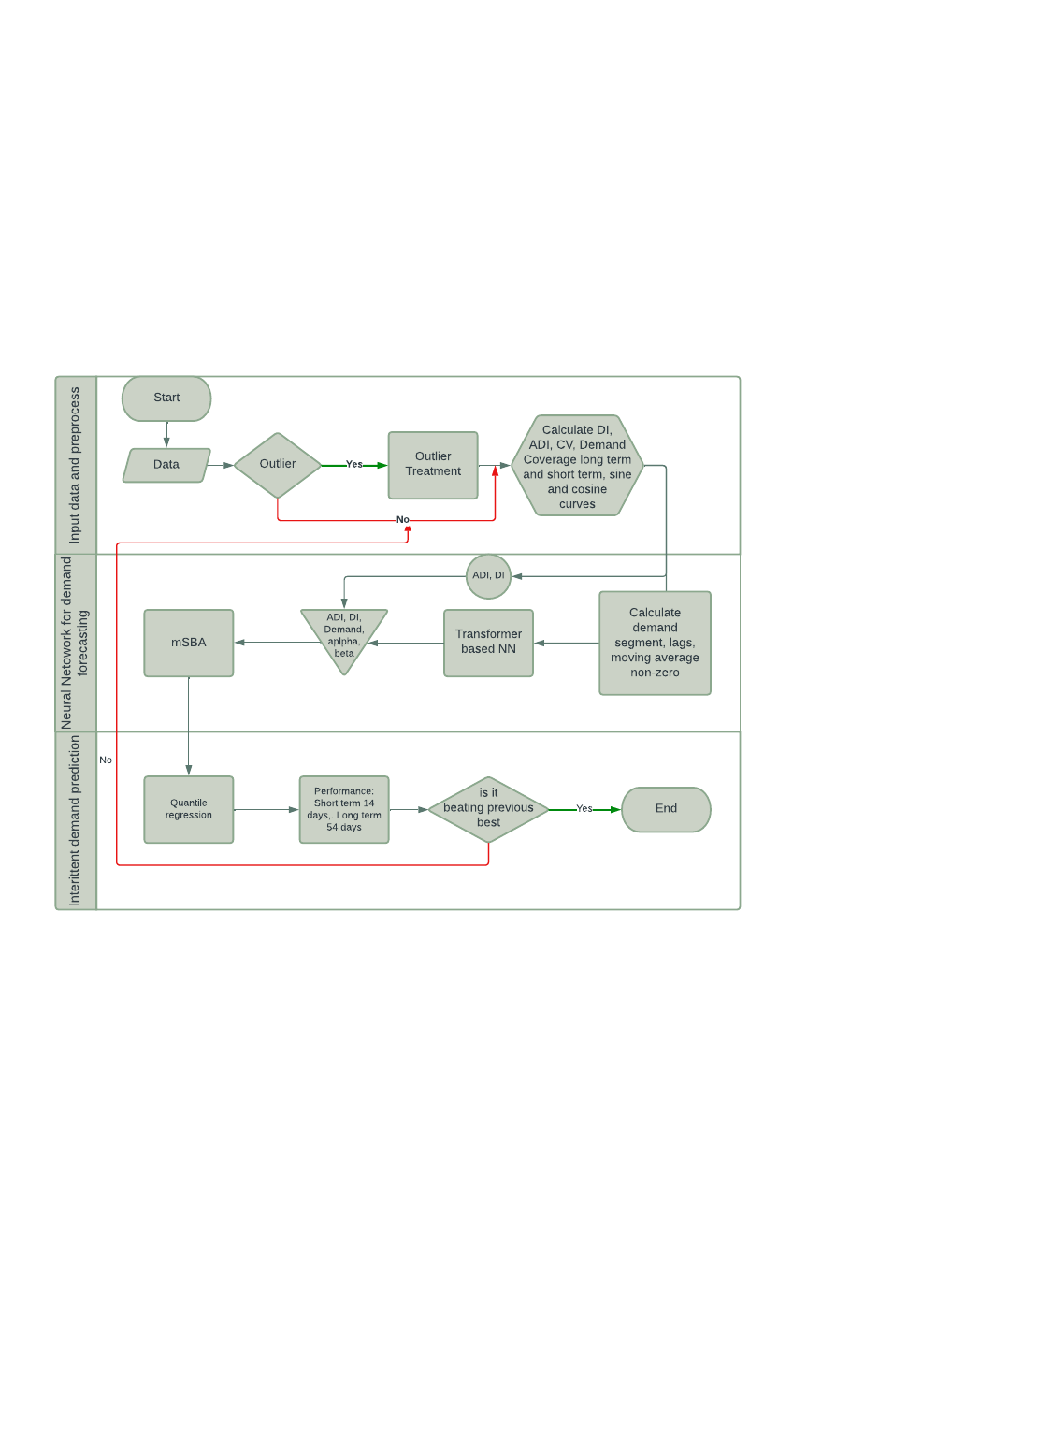

Figure .. Research Methodology Flowchart

## Data Description

For the purpose of the study three data sets for different domain are selected to examine the efficiency and robustness of the new research methodology under different domain.

* Dataset from Car Retailer
* Walmart Retail sample dataset
* Banking and financial

Table : Data Description

|  |  |  |  |  |
| --- | --- | --- | --- | --- |
| **S.No** | **Dataset Name** | **Number of Observations** | **Data Information** | **Dataset Link** |
| 1 | M4 Makridakis forecasting Competition | 1,00,000 | Car Retail Data set contains yearly, quarterly, monthly and other (weekly, daily and hourly) data, divided into training and test sets. | Link: [M4-methods/Dataset at master · Mcompetitions/M4-methods · GitHub](https://github.com/Mcompetitions/M4-methods/tree/master/Dataset) |
| 2 | M5 Competition dataset | 42000 | Walmart Retail hierarchical time-series dataset | Link : [GitHub - Mcompetitions/M5-methods: Data, Benchmarks, and methods submitted to the M5 forecasting competition](https://github.com/Mcompetitions/M5-methods) |
| 3 | Computational Intelligence in Forecasting (CIF) 2016 dataset | 72 Time-series | Baking and financial CIF dataset contains 72 time-series , off which 24 is real-time and 48 are artificial. | Link : [CIF 2016 Dataset | Zenodo](https://zenodo.org/record/4656042#.ZB2ZCcJBy8w) , Link2: [CIF - Competition Data Download (osu.cz)](https://irafm.osu.cz/cif/main.php?c=Static&page=download) |

## Data Exploration and Pre-process:

Data Exploration this process includes

* Descriptive analytics by calendar attributes such as Year, Month, Quarter, week start/end etc.
* Analysis statistical attributes such as variance, coefficient of variation (Moving and overall), change in overall vs moving w.r.t to different statistical attributes.
* Creation of smoothed data after outlier treatment
* Missing value treatment (if any)
* Time-series visualization and distribution analysis with respect to different calendar attributes

## Feature Engineering

After analysing time-series distribution with respect to different statistical attributes it is necessary to categorize data for forecastability with respect to square of coefficient of variation CV2 and average demand interval (ADI) as stated by Syntetos (Syntetos and Boylan, 2005) .

**Average Demand Interval (ADI):** This measures the regularity in demand by calculating the average time interval between two demands.

**Square of Coefficient of Variation (CV2 ) :** This is able to explain that how stable demand is, it provides variations in demands.

CV2 and ADI are being used to create demand profile into different categories. Smooth demand is easy to forecast, Intermittent demand have high ADI and irregular demand interval with fixed set of demand that which can also be in multiples. Erratic demand has regular demand, however, demand have high variation and often don’t follow historical pattern thus are accuracy for erratic demand is always unstable. Lumpy demand is most difficult to predict as they have high ADI and high variation, thus neither demand occurs at regular interval nor in a predictable quantity, we can say that lumpy demand is almost unforecastable. (Bartezzaghi and Kalchschmidt, 2011; Petropoulos and Kourentzes, 2015)

Further, usage of long term and short-term cumulative demand and demand coverage, short term demand interval, and overall demand interval. Other calendar variables such as year, month, week, monthly, weekly averages etc. will be part of data preparation process. In addition to this, it is very important for a time-series forecasting to capture the dependency of future forecast over lag forecast, hence lag variables will also be calculated, similarly sine and cosine curves based on actuals will be calculated to be ingested to neural network.

## Hybridization of Neural Network mSBA, and Quantile Regression for Demand Forecast

Further, neural network will be used to generate level-1 long term forecast and its output will be as input to modified SBA, where exponential smoothing ADI, current demand interval will be used to predict next forecast as penalized value in case we have zero demand as historical values and non-penalized when we observe continuous sales. Next Quantile regression will be used to predict quantiles and provide protection from excess or low stock levels.

## Performance evaluation

One way to assess the accuracy of predictions in the retail sector is to consider the time horizon of the forecast. There are two main types of time horizons: short-term and long-term. Another important factor is the lag between the forecast and the actual outcome. The lag can be either short (lag1) or long (lag4). Suggested performance matrix: Accuracy, Bias, Root mean square error(RMSE) , Mean Square error (MSE), Mean Absolute Percentage Error (MAPE). However, as dividing by zeros gives us infinite values hence Mean arctangent absolute percentage error (MAAPE) (Kim and Kim, 2016) is also suggested for intermittent time-series forecasting. In addition to above Hyndman in 2006 (Hyndman, n.d.) proposed mean absolute scaled error (MASE) which uses sample baseline forecast error and making this as appropriate measure irrespective of time horizon.

Table : Forecast Evaluation Parameters

|  |  |
| --- | --- |
| Forecast horizon: short term | 14 days/weeks |
| Forecast horizon: long term | 26 days/weeks |
| Evaluation lags | Lag1 and Lag4 |
| Evaluation metrics | RMSE, MAPE, WMAPE, MAAPE , MASE , Accuracy, |

# Requirements Resources

## Software Requirement

Programming Language: Python Version 3.10.10

Integrated Development Environment (IDE): Jupyter

Table : Software Requirement

|  |  |
| --- | --- |
| **Python Package** | **Version** |
| Pandas | Latest Version |
| Numpy | Latest Version |
| Matpoltlib | 3.5 |
| Sklearn | 1.2.2 |
| ISOweek | Latest Version |
| Seaborn | 0.12.2 |
| Torch | 2.0.0 |
| pytorch-lightning | 2.0.2 |
| Keras | 2.12.0 |
| Tensorflow | 2.9.0 |
| Sktime | 0.18.0 |
| Statsmodels | 0.14.0 |
| Pytorch-forecasting | 1.0.0 |

## Hardware Requirement

Minimum GPU : T4,

RAM : 128 GB

Processor : NVIDIA

# Research Plan

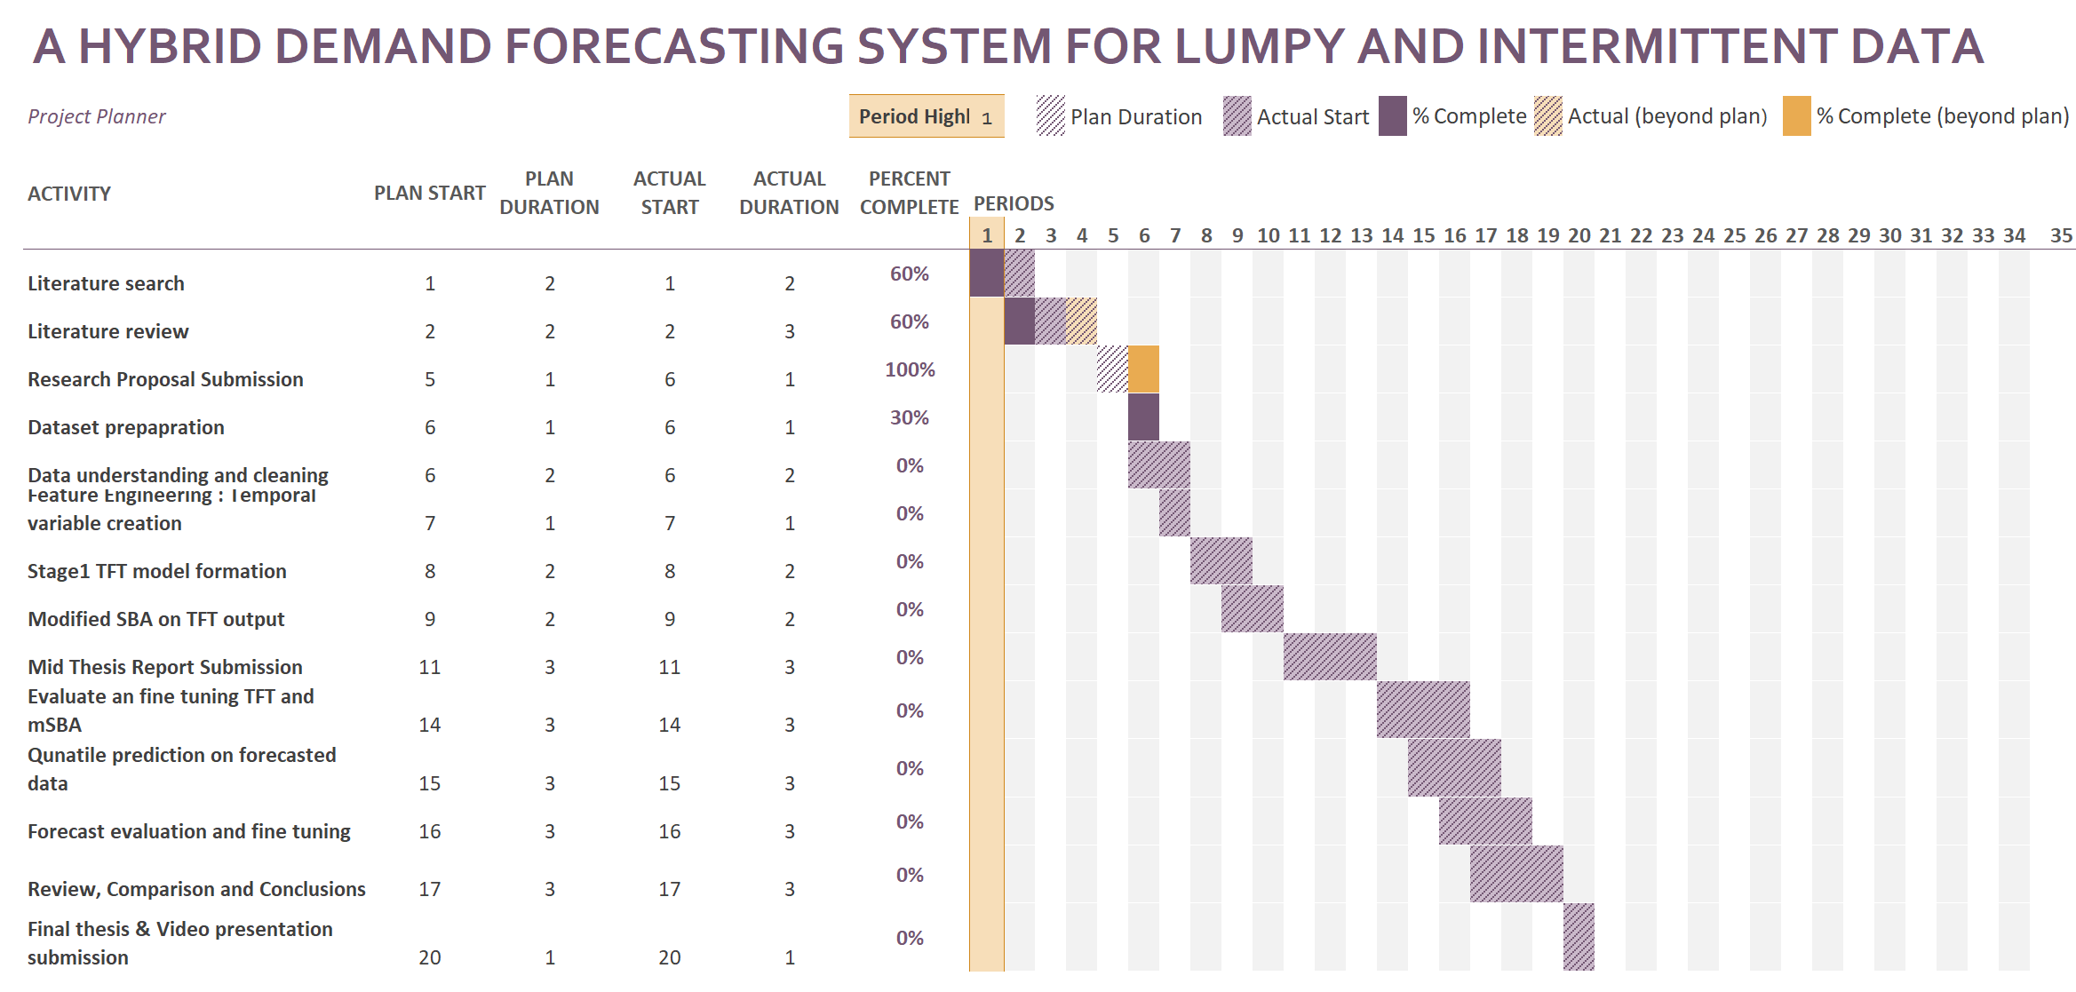

Figure .: Research Plan

# References

Abolghasemi, M., Hyndman, R.J., Tarr, G. and Bergmeir, C., (2019) Machine learning applications in time series hierarchical forecasting. [online] Available at: http://arxiv.org/abs/1912.00370.

Aburto, L. and Weber, R., (2007) Improved supply chain management based on hybrid demand forecasts. *Applied Soft Computing Journal*, 71, pp.136–144.

Aye, G.C., Balcilar, M., Gupta, R. and Majumdar, A., (2015) Forecasting aggregate retail sales: The case of South Africa. *International Journal of Production Economics*, 160, pp.66–79.

Bartezzaghi, E. and Kalchschmidt, M., (2011) The impact of aggregation level on lumpy demand management. *Service Parts Management: Demand Forecasting and Inventory Control*, pp.89–104.

Boylan, J.E., Syntetos, A.A. and Karakostas, G.C., (2008) Classification for forecasting and stock control: A case study. In: *Journal of the Operational Research Society*. Palgrave Macmillan Ltd., pp.473–481.

Chang, P., Li, H., Quan, S.F., Lu, S., Wung, S.-F., Roveda, J. and Li, A., (2023) TDSTF: Transformer-based Diffusion probabilistic model for Sparse Time series Forecasting. [online] Available at: http://arxiv.org/abs/2301.06625.

Choi, E., Bahadori, M.T., Sun, J., Kulas, J., Schuetz, A. and Stewart, W., (2016) Retain: An interpretable predictive model for healthcare using reverse time attention mechanism. *Advances in neural information processing systems*, 29.

Croston, J.D., (1970) *Forecasting and Stock Control for Intermittent Demands*. [online] *Source: Operational Research Quarterly*, Available at: https://www.jstor.org/stable/3007885.

Eaves, A.H.C. and Kingsman, B.G., (2004) Forecasting for the ordering and stock-holding of spare parts. *Journal of the Operational Research Society*, [online] 554, pp.431–437. Available at: https://link.springer.com/content/pdf/10.1057/palgrave.jors.2601697.pdf [Accessed 7 May 2023].

Ekiz Yilmaz, T., Yapar, G. and Yavuz, İ., (2019) TIME SERIES FORECASTING OF INTERMITTENT DEMAND BY USING ATA METHOD. *Mugla Journal of Science and Technology*.

Gutierrez, R.S., Solis, A.O. and Mukhopadhyay, S., (2008) Lumpy demand forecasting using neural networks. *International Journal of Production Economics*, 1112, pp.409–420.

Holt, C.C., (2004) Forecasting seasonals and trends by exponentially weighted moving averages. *International Journal of Forecasting*, 201, pp.5–10.

Hyndman, R.J., (n.d.) *ANOTHER LOOK AT FORECAST-ACCURACY METRICS FOR INTERMITTENT DEMAND*.

Hyndman, R.J. and Athanasopoulos, G., (2018) *Forecasting: principles and practice*. OTexts.

Johnston, F.R., Boylan, J.E. and Shale, E.A., (2003) An examination of the size of orders from customers, their characterisation and the implications for inventory control of slow moving items. *Journal of the Operational Research Society*, 548, pp.833–837.

Kim, S. and Kim, H., (2016) A new metric of absolute percentage error for intermittent demand forecasts. *International Journal of Forecasting*, 323, pp.669–679.

Lim, B., Arık, S., Loeff, N. and Pfister, T., (2021) Temporal Fusion Transformers for interpretable multi-horizon time series forecasting. *International Journal of Forecasting*, 374, pp.1748–1764.

de Livera, A.M., Hyndman, R.J. and Snyder, R.D., (2011) Forecasting time series with complex seasonal patterns using exponential smoothing. *Journal of the American Statistical Association*, 106496, pp.1513–1527.

Mitra, A., Jain, A., Kishore, A. and Kumar, P., (2022) A Comparative Study of Demand Forecasting Models for a Multi-Channel Retail Company: A Novel Hybrid Machine Learning Approach. *Operations Research Forum*, 34.

Mohammed, A., (2020) Towards ‘gresilient’ supply chain management: A quantitative study. *Resources, Conservation and Recycling*, 155.

Pai, P.F. and Lin, C.S., (2005) A hybrid ARIMA and support vector machines model in stock price forecasting. *Omega*, 336, pp.497–505.

Petropoulos, F. and Kourentzes, N., (2015) Forecast combinations for intermittent demand. *Journal of the Operational Research Society*, 666, pp.914–924.

Rao, A.V., (1970) *A Comment on: Forecasting and Stock Control for Intermittent Demands*.

Sillanpää, V. and Liesiö, J., (2018) Forecasting replenishment orders in retail: value of modelling low and intermittent consumer demand with distributions. *International Journal of Production Research*, 5612, pp.4168–4185.

Sousa, M., Tomé, A.M. and Moreira, J., (2022) Long-term forecasting of hourly retail customer flow on intermittent time series with multiple seasonality. *Data Science and Management*, [online] 53, pp.137–148. Available at: https://doi.org/10.1016/j.dsm.2022.07.002 [Accessed 1 May 2023].

Syntetos, A.A. and Boylan, J.E., (2001) On the bias of intermittent demand estimates. *International Journal of Production Economics*, 711–3, pp.457–466.

Syntetos, A.A. and Boylan, J.E., (2005) The accuracy of intermittent demand estimates. *International Journal of Forecasting*, 212, pp.303–314.

Syntetos, A.A., Boylan, J.E. and Croston, J.D., (2005) On the categorization of demand patterns. *Journal of the Operational Research Society*, 565, pp.495–503.

Taylor, S.J. and Letham, B., (2018) Forecasting at Scale. *American Statistician*, 721, pp.37–45.

Teunter, R.H. and Duncan, L., (2009) Forecasting intermittent demand: A comparative study. *Journal of the Operational Research Society*, 603, pp.321–329.

Williams, T.M., (1984) *Stock Control with Sporadic and Slow-Moving Demand*. [online] *Source: The Journal of the Operational Research Society*, Available at: https://about.jstor.org/terms.

Winters, P.R., (1960) Forecasting sales by exponentially weighted moving averages. *Management science*, 63, pp.324–342.

Yang, Y., Ding, C., Lee, S., Yu, L. and Ma, F., (2021) A modified Teunter-Syntetos-Babai method for intermittent demand forecasting. *Journal of Management Science and Engineering*, 61, pp.53–63.